Chapter 13, Problem 80.

Rework Prob. 13.22 using PSpice.

Chapter 13, Problem 22.

Find current I_{o} in the circuit of Fig. 13.91.

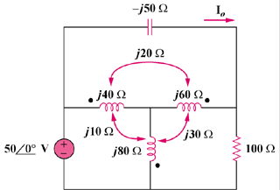

Figure 13.91
For Probs. 13.22 and 13.80.

